📌 Problem Statement 1: Campaign Effectiveness Analysis
Objective:
Analyse the effectiveness of email marketing campaigns to understand how well each campaign performs at different stages of the marketing funnel.
Business Questions:
- How many emails were sent for each campaign?
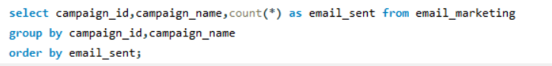
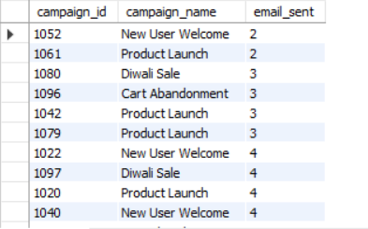
- What is the open rate and click-through rate for each campaign?
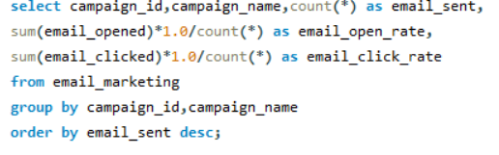
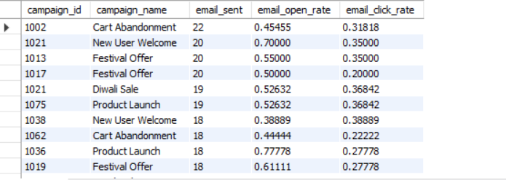
- Which campaigns lead to the highest number of purchases?
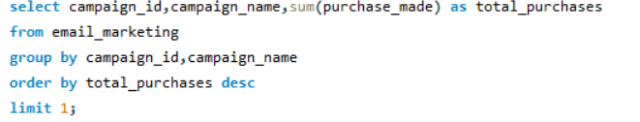
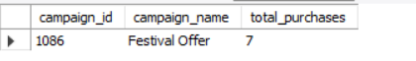
- Which campaigns have conversion rates higher than the overall average?
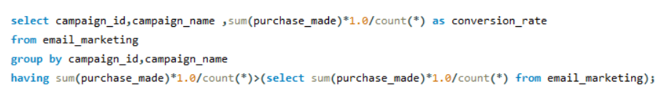
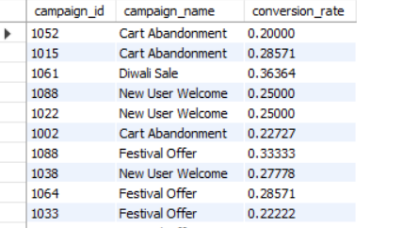

📌 Problem Statement 2: Customer Behaviour Analysis
Objective:
Understand customer engagement and behaviour patterns based on their interaction with marketing emails.
Business Questions:
- How do customers behave after opening or clicking emails?
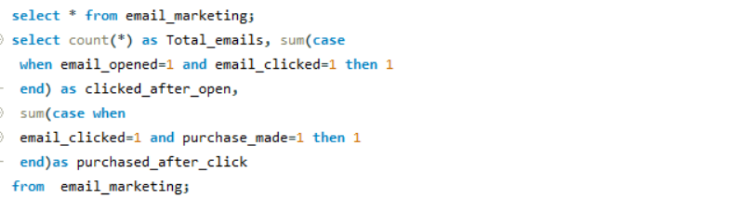

- Which customers consistently open emails but never make a purchase?
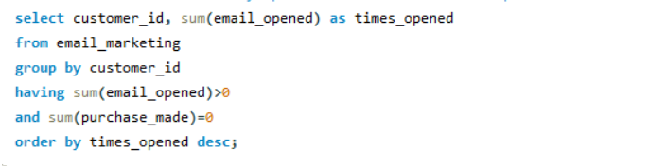
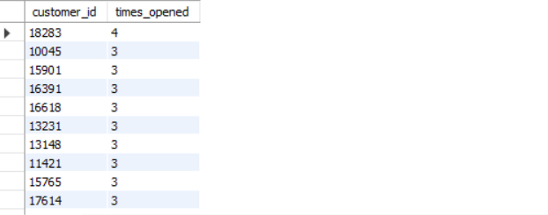
- What is the impact of device type (Mobile, Desktop, Tablet) on open and click behaviour?
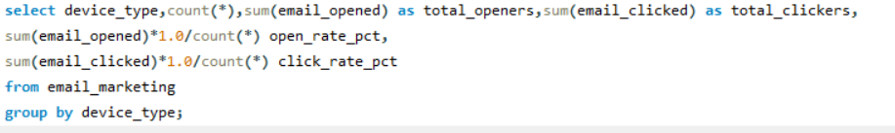
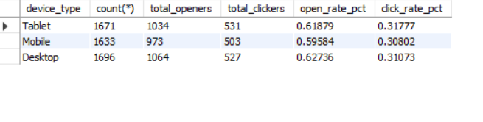
- Which cities show the highest customer engagement?
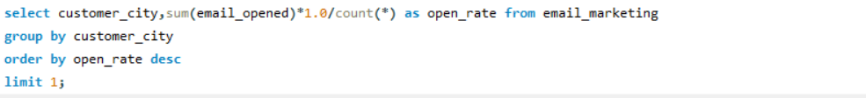
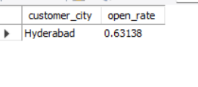
📌 Problem Statement 3: Revenue Impact Analysis
Objective:
Evaluate the revenue contribution of email marketing campaigns and identify high-performing segments.
Business Questions:
- How much total revenue is generated by each campaign?
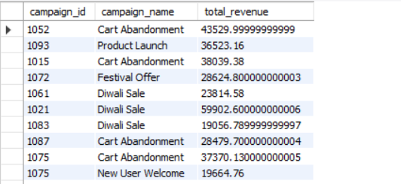
- Which campaigns generate the highest average order value?
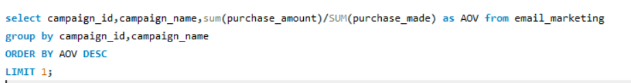
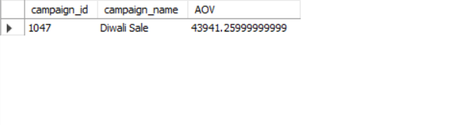
- What is the revenue contribution by city and device type?
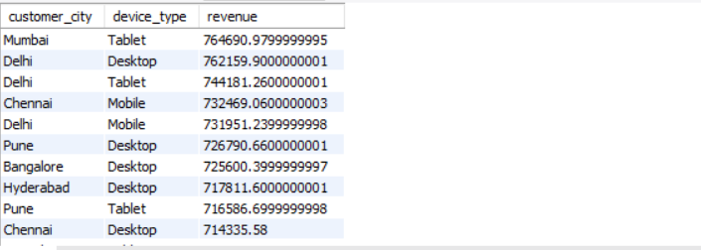
- Which campaigns contribute to the top 80% of total revenue?
